ADTA 5750: Assignment 5
Conversational AI System: System Analysis

PART I: Conversational AI System: System Analysis (100 Points)
- Introduction
To book a car when arriving at a new city can sometime be challenging and frustrating. Team 6 decided to address this problem and came up with an idea of “CarsToGo”.
- Problem statement
CarsToGo is a chatbot designed to book a rental car. This chatbot is meant to solve some practical problems faced by people when arriving in new cities which include:
- late night arrivals
- unreliable/stale information
- complicated process to book a car rental
- delays due to high volume of customers etc.
- System Requirements Analysis
  - Business requirements
The business requirements for the chatbot are based on the customer experience and revenue generation.
  - Enhanced customer experience: People often face get frustrated while booking a car rental as it is a time-consuming process. Our chatbot focuses on providing an enhanced customer experience.
  - Convenient and automated system: As the chatbot is fully automated, it cuts down the wait time.
  - Reduced operational cost for customer support: As the chatbot works without human intervention, it reduces the cost significantly.
  - Efficiency: Increased efficiency as the chatbot can handle multiple customers’ requests once
  - More revenue, retention and satisfaction: The chatbot implementation increases revenue, customer retention and satisfaction due to low waiting times and information accuracy.

  - Technical requirements
The conversational chatbot will be developed using DialogFlowCX by Google cloud platform. This platform provides us the required resources to build a chatbot which can handle complex conversations involving multiple intents and flows. With DialogFlowCX, we can also test the chatbot and improvise.
Components Used:
- Flows
There are multiple flows that we have identified for building this chatbot. Some of them are shown below. Please note that these not the final flows, we are still working on it.
  - Catalog
  - My Booking
  - My Booking Cancellation
  - My Booking Status
  - Customer Care
  - End Flow
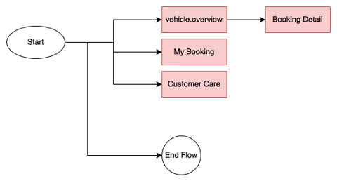

- Pages:
We have designed a few pages with respect to the flows identified so far.
Some of them are shown below.
  - Start page
  - Type overview
  - Seater
  - Price
  - Fuel type
  - Vehicle class overview
  - Drive type
  - Insurance
  - Confirmation
  - End session
  - End Flow
  - Booking details
  - My reservations

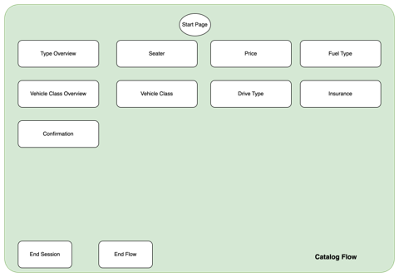

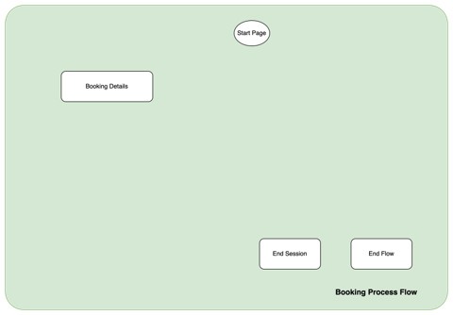

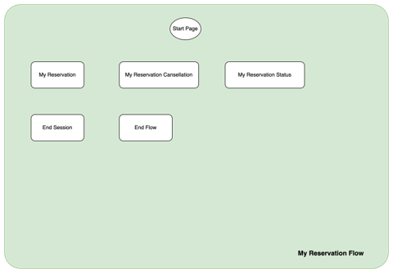
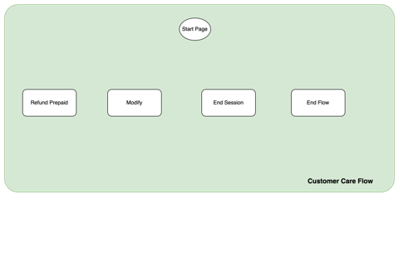
- Intents:
We have identified some intents based on our mock booking conversation and brainstorming sessions.
  - redirect.vehicle.overview
  - redirect.services
  - redirect.car.insurance
  - redirect.my.booking
  - redirect.price
  - redirect.my.booking.status
  - redirect.my.booking.canceled
  - redirect.refund.info
  - redirect.booking.process
  - confirm.proceed.booking
  - decline.proceed.booking
  - redirect.home
  - redirect.end
  - redirect.location

  - Data requirements
We have created the data model shown below. We have presented the same in the class.
- Vehicle class
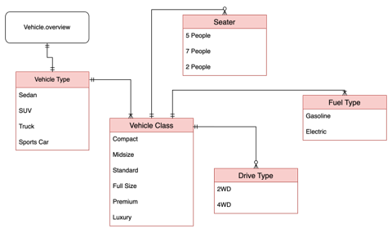
- My Booking
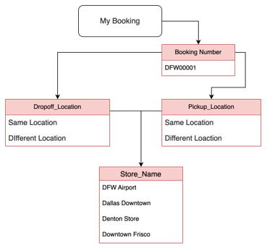
- Customer Care
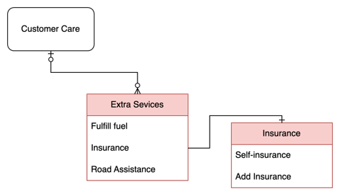
- Booking Detail
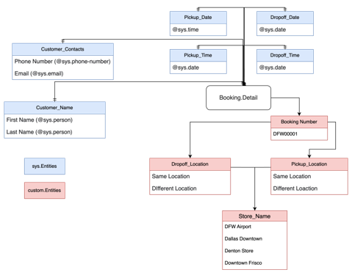

We have also created the below mentioned “Intent to Entity Mapping”.
- Redirect.vehicle.overview
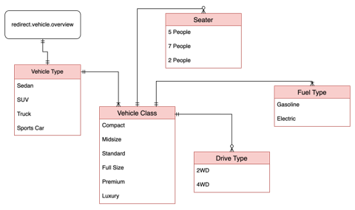
- Redirect.services
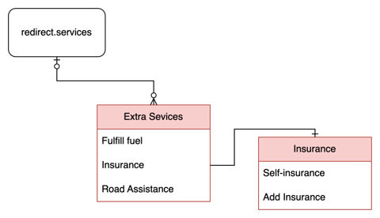
- My.booking
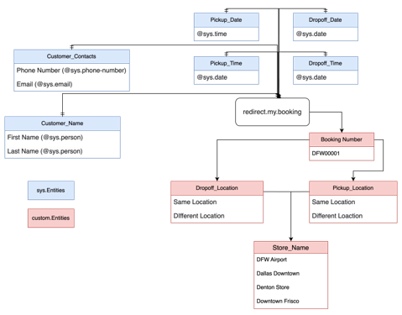

- Feasibility Analysis
- Technical feasibility analysis:
  - Can we complete the project successfully as required?
Answer: DialogFlowCX has a pretrained language model which is being leveraged in this project. DialogFlowCX provides a robust system on which we can build chatbot having complex flows.

  - Discuss any technical risks while working on the project
Answer: We have not faced any technical issues so far.

- Business feasibility analysis:
  - Will the project provide good business values after its completion?
Answer: We believe the system will provide good business values as it is aimed towards solving a practical problem.
    - Reduced operational cost for customer support: As the chatbot works without human intervention, it reduces the cost significantly.
    - Efficiency: Increased efficiency as the chatbot can handle multiple customers’ requests once
    - More revenue, retention and satisfaction: The chatbot implementation increases revenue, customer retention and satisfaction due to low waiting times and information accuracy.

  - Discuss any financial risks while working on the project, e.g., running out of funding
Answer: There are minimal financial risks involved in the project.
Fully Automated Chatbot: This is a fully automated chatbot hence no human interference is required.
Transparency for Payment Model in DialogFlowCX: DiallogFlowCX is a part of GoogleCloud Platform hence it has a transparent payment model where we can easilty track the cost and prevent any unnecessary spikes.

- Operation feasibility analysis
  - If we build the system, will it be used by the organization as expected?
Answer: Once the Chatbot is build and tested, it is expected to be operational. It should be able to handle the customer requests to book a car rental efficiently.
Testing: We will be performing a robust testing on this chatbot to ensure that is works as expected.
  - Discuss any risks that may hinder the deployment of the system after its completion.
Answer: We anticipate the system to work as expected. As we have a complete testing plan in place that can help us to make the system error-free. We do not anticipate any deployment risks at this point of time.

Project Management
- Discuss in detail the timeline of the project
  - What kinds of major tasks to be done?
Answer: We prepared the below project plan having the list of all major activities.
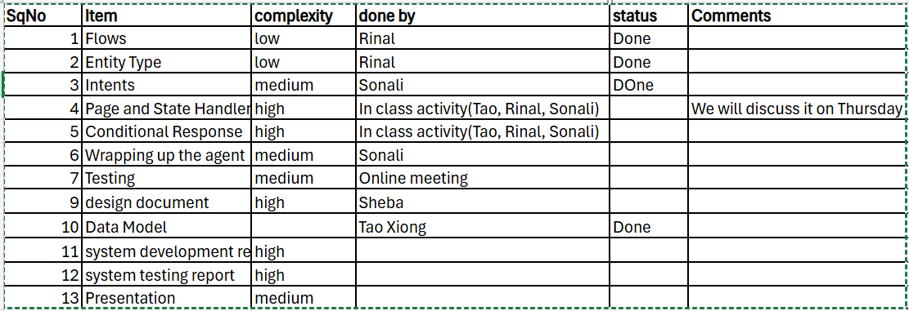
  - What major phases need to be done until the completion?
1. Due date of each phase or task.
Answer: The table below shows the major phases and target completion dates.
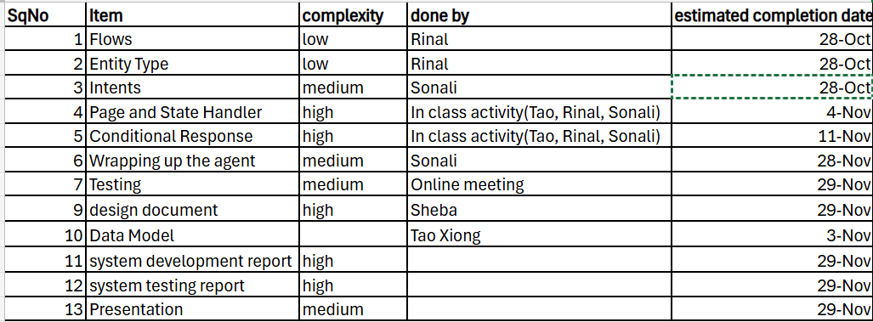
- Discuss in detail the human resources needed for the project
  - How many people, in total, are assigned to work on the project?
Answer: six people
Paladugu, Sheba Rani
Shah, Rinal
Sabnam, Sonali
Xiong, Tao
Anne, Rajesh
Akhila, Uppula

  - How many people are assigned to work on each major phase of the project?
Answer: All the people in the team are assigned work.
Paladugu, Sheba Rani
Shah, Rinal
Sabnam, Sonali
Xiong, Tao
Anne, Rajesh
Akhila, Uppula

  - For each phase, who do what?
Answer: A lot of our work group work and we connect every week before class and also online on Thursdays. For the rest of the week till submission, we will be meeting every day to discuss until the presentation day.
We are still deciding on the final model and there are a few tasks that needs to be assigned.

Conclusion
There were many challenges that we encountered while working on the project. However, with open discussions with the team and collaboration we could mitigate these challenges and come up with a successful project plan and a chatbot with the required functionality.

